**Solution Offered**

Project Name: **Decoli - DEvice of COgnitive Listening**

Author: Suryasaradhi (Btech Eng. Physics 2018 - 2022)

*Problem Statement Identified and Current Situation:*

* Designing a headset type portable SDR
* capable of language processing
* Automatic modulation detection and decoding
* Requested Frequency Range: VLF to Ka band : 15khz - 40Ghz
* Long Battery Lifetime

The problem statement is targeted for creating a eavesdropping device , that can be carried on the fly by soldiers, Agents , Military personals etc. Unlike its heavier SDR counterparts which require a separate software end (PC) Decoli does not need another piece of equipment to function, it is all packaged into a small device. The portability guarantees easy use and spot decoding of RF waves transmitted behind enemy lines. The intuitive interface and design significantly reduce the setup time needed for the device to be operable.

Current devices need separate carry bags, Are bulky, Are power hungry as they need huge Power Adapters, Does not have integration with cutting edge technologies. The innovation Decoli brings forth kicks all these problems off the table.

*Proposed Solution:*

See Realtime updates of the project at – [**https://github.com/thesunRider/decoli**](https://github.com/thesunRider/decoli)

The proposed solution was a straight forward implementation of the problem statement. The RF signal was tuned down into an IF Frequency, sampled it over an ADC and sent it over to a Linux operating system where it was processed decoded and played back to the user.

* Implementation Procedures

The concentration was on building the hardware by keeping in mind the form factor reached in Stage 1 where a designed first prototype was made with tuned down specifications.

**Stage 1** was practically a Raspberry Pi Zero W stacked on an RTL SDR PCB Board, The Pie getting powered from a Battery management IC TP4056, Using PWM an audio output was received from the Pie to earphones fed to the user. A wire was extended throughout the length of the earphone wire which is used as an antenna.

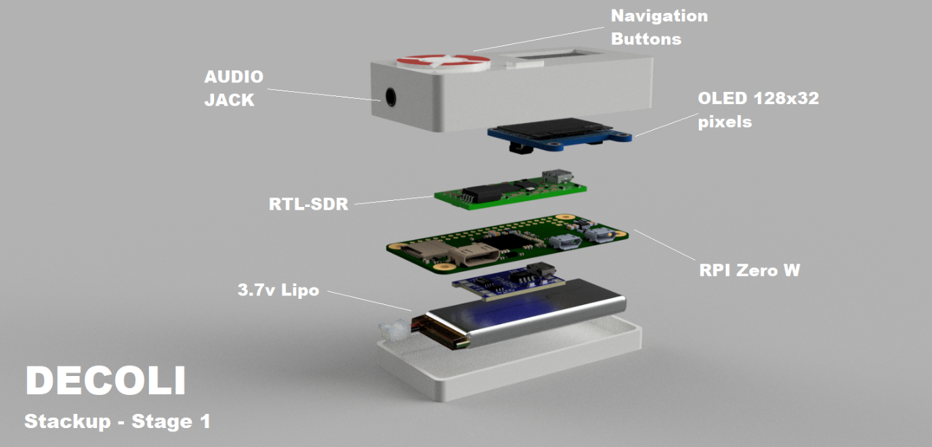

This prototype was the quickest road to a prototype, taking this model as our reference and based on our design with keeping the architecture same, combining everything to a single board. The biggest problem with Stage 1 was it was not production ready, as it used several components that were all separate and **COPYRIGHTED PRODUCTS.** Furthermore, the device has now become very bulky. These problems were solved in Stage 2, while physically at Stage 1. The materials were designed to fabricate for stage 2, which would proceed to materialize shortly.

Figure Flow Diagram of Stage 1 Prototype

* Specifications

Specification Initial prototype:

|  |  |
| --- | --- |
| **Form Factor of Motherboard** | Large [70mm x 35mm x 20mm] |
| **Inter-Connections** | Separated |
| **Technologies Used** | RTL SDR, Raspberry Pi Zero W, Display Module, Battery Management Module |
| **Software Technologies Used** | Python, SDR#, GCP, SVM AI, Data Classification, Universal Radio Hacker (URH platform), GNU Radio |
| **Achieved in Hardware** | * Able to Receive Full RTL SDR Spectrum * Able to Hear audio from radio transmission * Able to Display and navigate the radio platform. * Able to Recharge and reuse battery |
| **Achieved in Software** | * Foundations for GUI of Oled * AI classifier added, that detects modulation schemes * Playback AM, FM, CW Schemes * Translator service calls added |

**Stage 2**, Combining all the non-copyrighted products into a single 6-layer PCB design, drastically reduced size. The new product looks different though comes with the same software architecture from our first prototype, thus the code needs simply be forwarded to this prototype. There are major hardware changes as Raspberry Pi boards itself is copyrighted, had to move onto NUC980, a Nuvoton Embedded Linux IC. RTL SDR was also copyrighted so, the datasheets were gathered of the Tuner and the DSP and created the circuit from scratch, The end circuit is a 3 sheet PCB schematic which was completely built from scratch and assembled to a 6-layer PCB.

* Circuit Schematics of Stage 2 prototype

In our PCB, an embedded Linux layer was present, which have Linux running, this design block uses the bottom two PCB layers, these layers are also shared by the Wi-Fi provider ESP8266 which provides internet connectivity to the OS through i2c. (WITH CIRCUIT DISCUSSED IN BRIEF OF TECHNOLOGY)

* Specifications

Specification of Stage 2 to be prototype

|  |  |
| --- | --- |
| **Form Factor of Motherboard** | Medium [57mm x 27mm x 10mm] |
| **Copyright infringement** | NONE |
| **Inter-Connections** | All On Single board |
| **Hardware Technologies** | * Wi-Fi - 2.5G – Onboard Antenna * HF Direct Sampling Mode * <1 PPM temperature compensated oscillator (TCXO) * Embedded Display and Navigation Controls * Battery Life up to 3 Hours * Oled Display * 3.7V Bias Tee * Switchable Boot Configuration (USB/SD Card) * Dedicated 24-bit Audio Chip for best quality. |
| **RF Technologies** | * Full RF Spectrum Sweep * Demod RF Transmissions * Save/Play Transmissions |
| **AI Technologies** | * Detection and Demod of Signals * Translation using GCP |
| **Frequency Sweep** | 500Khz – 1766 MHz **(BW: 3.2Mhz)**  (I have left Space for adding a downconverter for increasing frequency) |

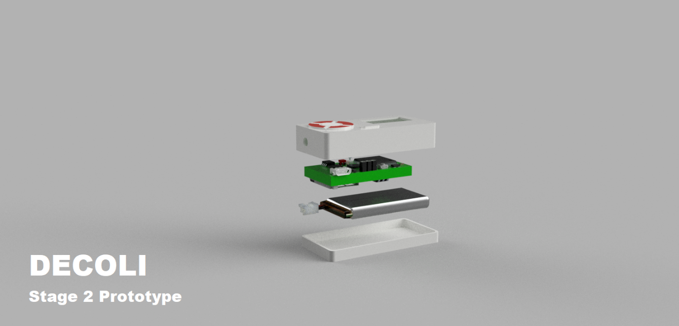

Figure Decoli Stage 2 Prototype ( Condensed PCB)

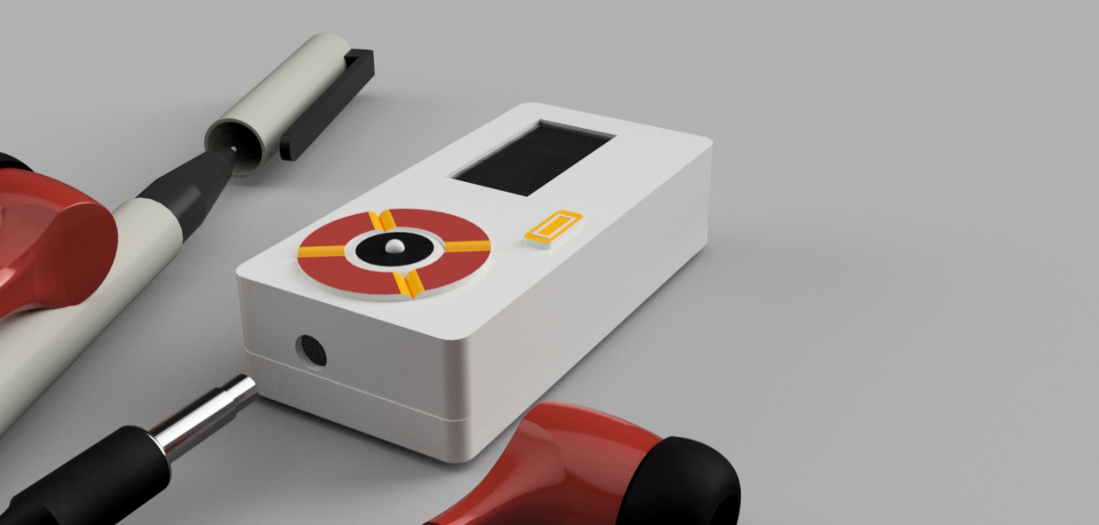

Figure Decoli Stage 2 prototype, View for Size comparison

*Future Scope*

* **Implement downconverter and a LNA for extending frequency range**
* Software switchable boot mode
* Decrease size and Increase battery lifetime by replacing LDO’s with buck converters
* **PCB Impedance matching (Recheck)**
* Implement Complete GCP translation services
* Implement Complete GUI
* Implement Buck switching converters for stepping up 3.7v to 5V for smoother operation of Nuvoton processor.
* **LC filters for power supply ripple filters.**
* Charge level indicator based on current flow.
* Write modular Software classes

So far, we have been majorly concentrating on the hardware part of the design, we have tried to compact the size of the product as much as possible and tried to make a device completely from scratch without copyright infringements. The software side has been bare bone implementation, and needs more work to be done. I have researched further into the implementation architectures of SDR’s and capability of the tuner and DSP used, I will be able to leverage more of the features offered by the chipset such as carrier tracking, Filter impedance matching on the future revisions.

*Conclusion*

The device will undoubtedly help in espionage and data gathering, with its compact form factor and intuitive design it is a go-to product that can be used as a standalone product. Due to its small architecture, it has a very small footprint thus it is a Quick-Blaze device. The device will prove to be an asset to the EMSO wing of the Indian army once all its features are implemented.